Steps to do ECS SC with https:
- Create namespace -NS
- Create ECR containers-Dockers>
- Create VPC-ALB-SG-TG-subnet- (intf End point), IG, Endpoint GW
- Cluster>
- Task definition>
- Services>
- ACM- public>
- Private CA>internal
- Testing

Next task:
Allow only defined ports like 443
Port customization with others
DNS, port aliases port
----
Amazon VPC lattice vs ECS SC vs DS comparison:
Service Connect offers a significant advantage over plain Cloud Map for service discovery by providing faster failover when service instances go down. With Service Connect, your applications can use short names and standard ports to connect to Amazon ECS services in the same cluster, other clusters, including across VPCs in the same AWS Region. It used a built-in container name, Service Connect Agent. It combines features from Cloud Map, ELB, Service Discovery, and App Mesh.
https://github.com/aws/amazon-ecs-service-connect-agent
ECS service discovery: This approach to service-to-service communication provides low latency. This approach to service-to-service communication provides low latency. There are no extra components between the containers. Traffic travels directly from one container to the other container. The main disadvantage of direct service-to-service communication using service discovery is that you must implement extra logic to have retries and deal with connection failures. Client resolves <service namespace>.<hosted-zone name> to get backend Task IP addresses
Amazon VPC Lattice is a managed application networking service that Amazon ECS customers use to observe, secure, and monitor applications built across AWS compute services, VPCs, and accounts without having to modify their code. It can connect EC2, EKS, and Lambda, with cross-VPC and cross-account communication as their key strengths. Kind of replacement of ALB. VPC Lattice has time-based charges per Lattice Service. Time-based charges alone cost approximately $23.4 per month per Service (\$0.0325/h x 24 x 30)
For cost efficiency, it's better to associate multiple ECS services with one Lattice Service rather than creating a separate Lattice Service per ECS service (like ALB)
 | VPC Lattice | ECS Service Discovery | ECS Service Connect
In short | Evolution of ALB that connects everything | Simple name resolution | ECS-specific, easy & feature-rich
Release (GA) | 2023 | 2018 | 2022
Ease of setup & management | Medium | 👍👍Easy | 👍Relatively easy
💰Cost | Time + traffic + request count | 👍👍Very cost-effective | Sidecar
🔭Logs & Metrics | 👍Supported | 👿None | 👍Supported
🛡️Health Check | 👍Supported | 👍Supported (container level) | 👍Partially supported¹
🛡️Auto Retry | 👿None | 👿None | 👍Supported
🚢Supported Deployment Types | Technically all | 👍All | 👿ECS only
🚢Canary Deployment | 👍Easy | 👿Tricky | 👿Not possible
🐙Name Resolution from non-ECS | 👍Possible | 👍Possible | 👿Not possible
🐙Cross-VPC Communication | 👍👍Specialty | 👿Not possible | 👍Possible
🐙Cross-Account Communication | 👍👍Specialty | 👿Not possible | 👿Not possible

- "I use various services like EKS and Lambda besides ECS, and want to connect many VPCs/accounts" -> VPC Lattice
- "Simple name resolution is enough. Reliability and observability are not needed or will be implemented separately" -> Service Discovery
- "I want to connect ECS services with high reliability and observability. Communication with non-ECS services is minimal" -> Service Connect

How do AWS Private CA distribute and manage the certs with ECS?

Service Connect leverages short-lived certificates with frequent certificate rotation. You have the authority to modify the rotation frequency, disable, or delete the secrets using managed rotation in Secrets Manager, but doing so can come with the following possible consequences. Service Connect utilizes the infrastructure role provided to create secrets within Secrets Manager. These secrets are used to store the associated private keys for your TLS certificates for encrypting traffic between your Service Connect services.
https://docs.aws.amazon.com/AmazonECS/latest/developerguide/service-connect-tls.html

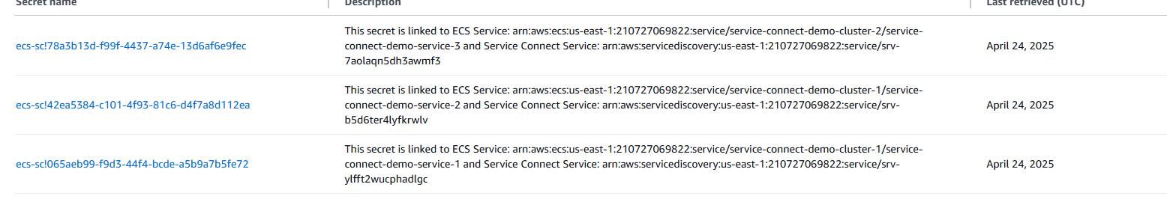
How can we ensure that we are using https to connect ECS?
https://aws.amazon.com/about-aws/whats-new/2024/01/amazon-ecs-service-connect-automatic-traffic-encryption-tls-certificates/
https://aws.amazon.com/blogs/compute/maintaining-transport-layer-security-all-the-way-to-your-container-part-2-using-aws-certificate-manager-private-certificate-authority/

We also checked the certificates inside the container as per below snapshots:

